Jason-Based Multi-Agent System for City Safety: A Simulation of Agents Cooperating to Arrest Criminals
Giulia Benvenuto
s4678610@studenti.unige.it

1. Introduction
The objective of this project is to use Jason which is an interpreter for an extended version of AgentSpeak, that provides a platform for the development of multi-agent systems in order to create a dynamic simulation of an environment representing a city
where police agents, civilian agents and clue agents with their different behaviours, cooperate to discover and apprehend criminals.

2. City Safety Problem
To understand why a Multi-Agent System (MAS) is well suited for addressing the city safety problem, it’s essential to analyse the problem at its core.
Safety is a key issue in city areas, affecting the happiness and the satisfaction of the city’s residents, for these reasons is reasonable to think that civilians living the city will collaborate with law enforcement, not only to enhance their personal safety but also to contribute to the overall security of the environment.
This collaboration typically involves sharing information useful to quickly find a criminal and arrest him as soon as possible.

3. Harnessing Multi-Agent Systems to solve the City Safety Problem
After the analysis of the general problem, we can easily understand why a simulation about city safety can be well represented by a MAS.
The inherent collaboration and cooperation exemplified in the city safety problem (between civilians, police, and eventually other agents) perfectly aligns with the capabilities of MAS, that generally are designed to simulate and manage complex interactions among multiple autonomous agents; moreover, they are particularly adept in simulations where the agents are working to achieve a shared and common goal.
Finally, leveraging the distributed intelligence and collaborative nature a MAS provides a good framework to demonstrate the cooperative effort of agents working together within the city to achieve safety.

4. Development Framework
To implement the multi-agent simulation for city safety I used a development framework that integrates multiple technologies, ensuring that the interaction between agents can also be visually tracked through a Graphical User Interface (GUI).
This GUI displays the dynamic movements of agents within the city environment, represented by a grid of cells, allowing for a more intuitive understanding of the agents’ position, of their communications and collaborative behaviours.

4.1 Jason
As outlined on the Jason official website: “Jason is an interpreter for an extended version of AgentSpeak. It implements the operational semantics of that language and provides a platform for the development of multi-agent systems.” [1]
Thereby, in this project, Jason’s capabilities define and manage the behaviours of four distinct types of agents, each dynamically interacting within the city environment.
These agents – police agents, civilian agents, clue agents and criminal agents – utilize Jason to manage their beliefs, goals and act accordingly.
This implementation allows each agent type to operate based on a distinct set of perceptions and objectives that influence their movement and interactions in the simulation.

4.2 Java
A portion of the project is developed in Java, stemming from the fact that Jason is built on Java. This aspect allows Jason to integrate with and extend Java’s capabilities.
This integration is crucial for Jason as it allows the enhancement and expansion of the functionalities of the Multi-Agent system, such as adding percepts dynamically to agents as they navigate the city.
In my project this integration is evident in the structure of three critical components: “CityEnvironment.java”, “CityModel.java” and “CityView.java” that extend Java-based classes specifically designed for Jason’s environment. More precisely they respectively extend “Jason.environment.Environment” [2], “GridWorldModel” [3] and “GridWorldView” [4].

5. Environment and Agents Design and Implementation
In the following section I will provide a detailed description of the implementation of both the city environment and the agents in the project.
This section will also include an in-depth examination of the most important files in the program, highlighting how each component contributes to the overall functionality and outcome of the system.

5.1 Run the code – crminals_and_agents.mas2j
To run the program move into the “MultiAgent_Systems” folder and run the following command: ./jason criminals_and_agents/criminals_and_agents.mas2j
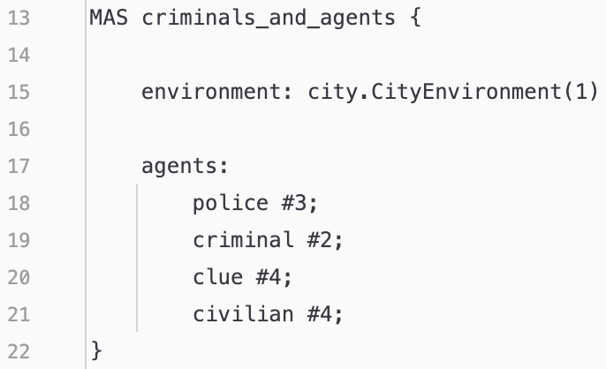
This is the core of the program since in it there is the configuration of the components of the MAS: environment and agents.
- environment: city.CityEnvironment(1)
is the setup of the environment calling the Java class responsible of it.
- agents: police #3; criminal #2; clue #4; civilian #4;
is the setup of the agents that will populate the environment. Where the hashtag and the following number define how many instances of each agent should be initiated.

5.2 Environment
The City Environment in this Multi-Agent system serves as the dynamic stage where agents perform their roles and interact. It is implemented through a structured architecture that involves the use of three Java classes that extend Jason classes: CityEnvironment, CityModel and CityView.
Each one of these components have a distinct role in defining, modelling, and visualizing the environment and the agents in it.
Together they aim to create an environment filled with agents and obstacles, mimicking real-world cities.

5.2.1 CityEnvironment.class
This is the Java class utilized by the .mas2j file to instantiate the city environment where the agents interact and navigate. It extends ”Jason.environment.Environment” that serves as the backbone for the dynamic space of the simulation offering some methods to manage agents such as: addPercept() or removePercept() (entire list of methods in the API documentation of the class [2]).
Such methods can also be overridden if needed to define specific behaviours.
To understand the responsibilities of this class we can look at the UML diagram:
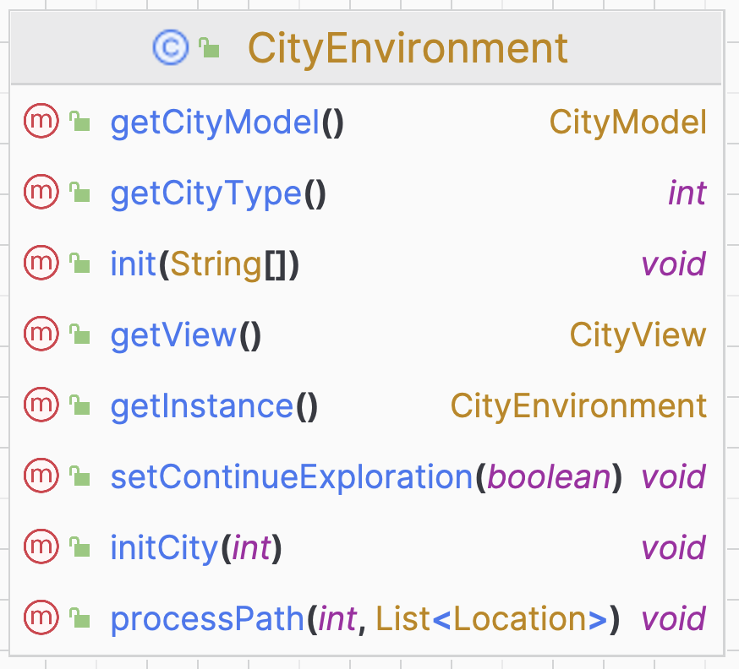
The class contains method to get or set variables and instances and the most critical and important methods are:
- init(String[]): that is fundamental for starting up the environment.
- processPath(int agId, List<Location> path): that handles the movement of police agents within the city grid following a path computed by the A* algorithm.

5.2.2 CityModel.java
This is the Java class that manages the creation of the grid representing the city, the state and the evolution of it during the simulation. This class extends “GridWorldModel” [3] from the Jason environment framework enabling the usage of the provided grid functionalities.
With this class we can associate a 40x40 grid to the environment and put in it all the dynamic and static entities:
- Obstacles: static objects, such as walls and houses that define the physical constraints of the simulation.
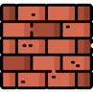 Wall obstacle  House obstacle

- Jail: static and designed location in the grid where arrested criminals are held.
 Free jail  One criminal in jail  Two criminals in jail
- Agents: of different types, having different roles and capabilities. Police agents are moving in the grid exploring it, other agents are fixed in some positions.
Police  Civilian Clue  Criminal

As before, to understand the responsibilities of this class we can look at the UML diagram:
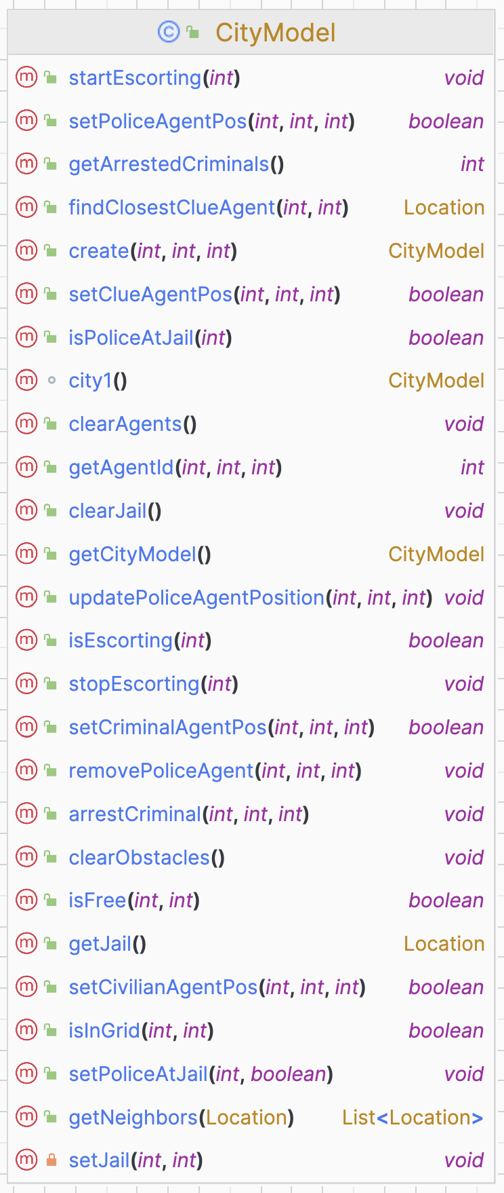
This class includes various methods. Before each method in the code, there is a comment explaining what the method does.
However, following I will describe the most important methods of the class:
- city1(): creates the city model, set in it all the agents by calling the methods “setNameofagentPos()”, set the position of the jail, set the position of obstacles.
- setPoliceAgentPos(): set the position of the police agents and add them the percepts about their own position and id and about the start, end positions and jail position.
- setCivlianAgentPos(): set the position of the civilian agents and add them the percepts about their own position and id and about the closest clue agent.
- setClueAgentPos(): set the position of the clue agents and add them the percepts about their own position and id and about criminal position X or Y.
- setCriminalAgentPos(): set the position of the criminal agents and to add them the percepts about their own position and id.
Then there are some methods to handle and track the state and the position of police agents like:
isEscorting(int), startEscorting(int), stopEscorting(int), isPoliceAtJail(int), updatePoliceAgentPosition(int, int, int), removePoliceAgent(int, int, int).
There are some methods are used for environmental manipulation such as:
setJail(int, int), getJail(), clearJail(), clearObstacles() and clearAgents().
And there are some utility methods:
getNeighbors(Location), findClosestClueAgent(int, int), isInGrid(int, int), ifFree(int, int)

5.2.3 CityView.java
This is the Java class designed to visualize the city environment and draw on it the agents and the obstacles. This class extends the “GridWorldView” [4] class of the Jason environment framework that provides all the view components for a GridWorldModel and methods to retrieve the width and the weight of the grid used.
So, this class is structured to manage and update the visual representation based on changes in the model.
As before, to understand the responsibilities of this class we can look at the UML diagram:
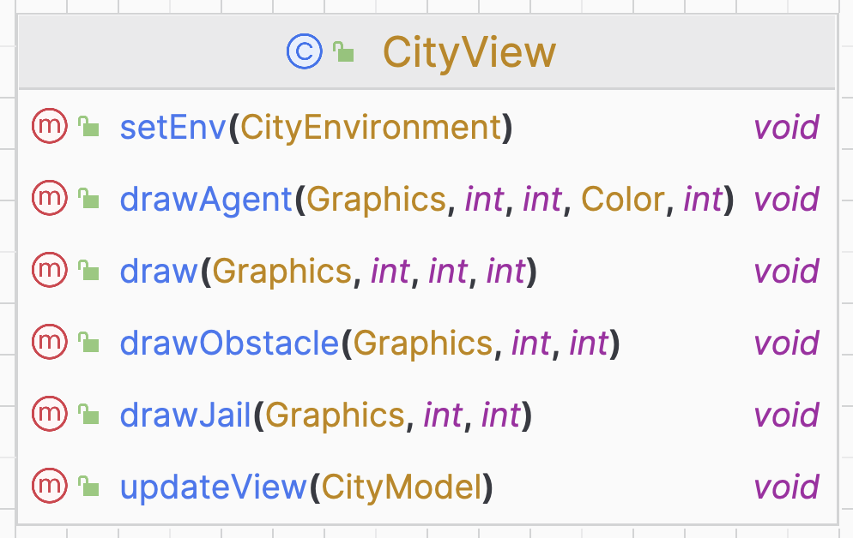
The class contains methods to draw:
- draw(Graphics, int, int, int): is the overridden method of the GridWorldView Jason class used to draw unknown object (obstacles and jail).
- drawAgent(Graphics, int, int, Color, int): is the overridden method of the GridWorldView Jason class used to draw the agents.
- drawObstacles(Graphics, int, int): is the method used to draw the obstacles with their icon.
- drawJail(Graphics, int, int) : is the method used to draw the jail with its icon.
- updateView(CityModel): is the method used to update the visualization of the city environment every time is needed.

5.2.4 City Environment Result
Using the components described in the previous sections, the city environment is visualized in a window that illustrates the dynamic movements of the police agents and statically represents the other agents and the obstacles.
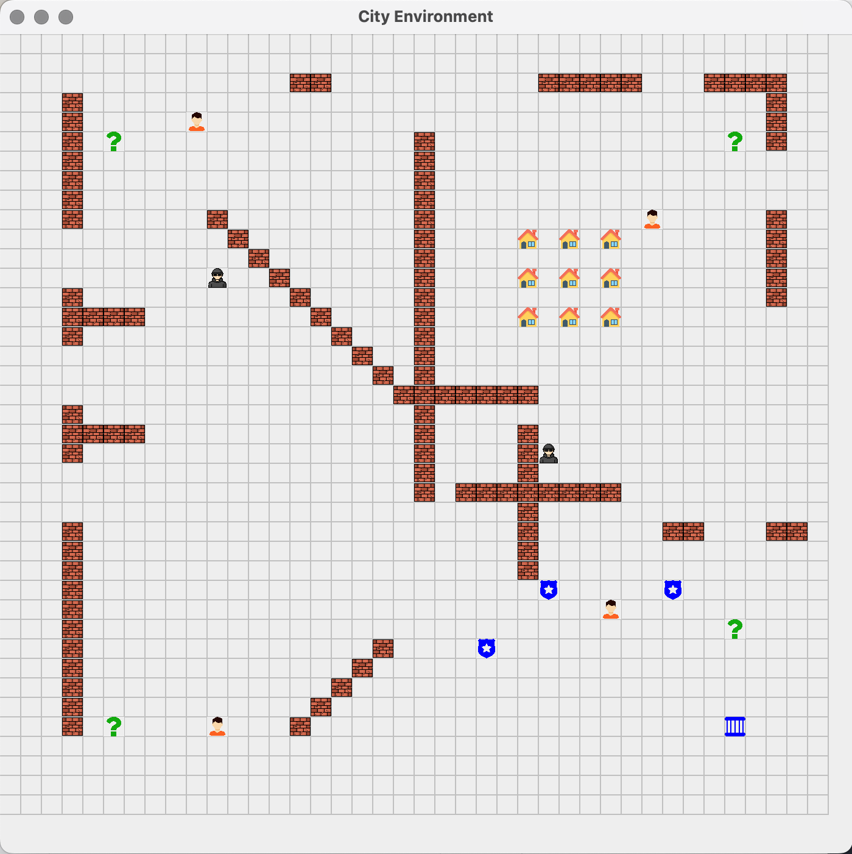
In addition to the graphical representation of the city there is also the MAS console.
This console offers a more detailed report of the agents’ behaviours and interactions:
- Agent path tracking: the console displays the paths of the police agents as a series of (x, y) coordinates. This gives a more comprehensive understanding of the police agent navigation within the grid.
- Agent communications: the console captures and displays the interactions between agents, including the exchange of messages and information. This is crucial to understand the coordination and the cooperativity of agents in order to achieve their objective.
where is possible to see the path of the police agents as a series of (x,y) coordinates and the interaction between agents with the messages and information that the sends one to the other.
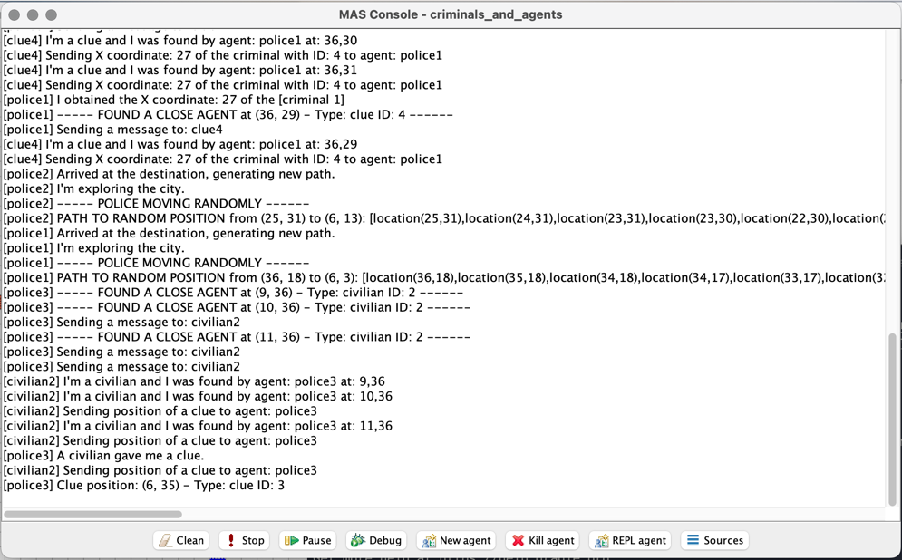

5.3 Agents

References
- “Jason: An Interpreter for AgentSpek”: https://jason-lang.github.io/#about-jason
- Jason.environment.Environment: https://jason-lang.github.io/api/jason/environment/Environment.html
- GridWorldModel: https://jason-lang.github.io/api/jason/environment/grid/GridWorldModel.html
- GridWorldView: https://jason-lang.github.io/api/jason/environment/grid/GridWorldView.html

Heading 1: Introduction (use this style for titles of sections)

Heading 1.1: (use this style for level two headings)

Heading 1.1.1: (use this style for level three headings)

